Question no 1 Factorial No

using System;

using System.Collections.Generic;

using System.Linq;

using System.Text;

using System.Threading.Tasks;

namespace Assignment_day_1_fact

{

public class FactorialExample

{

public static void Main(string[] args)

{

int i, fact = 1, number;

Console.Write("Enter any Number: ");

number = int.Parse(Console.ReadLine());

for (i = 1; i <= number; i++)

{

fact = fact * i;

}

Console.Write("Factorial of " + number + " is: " + fact);

}

}

}

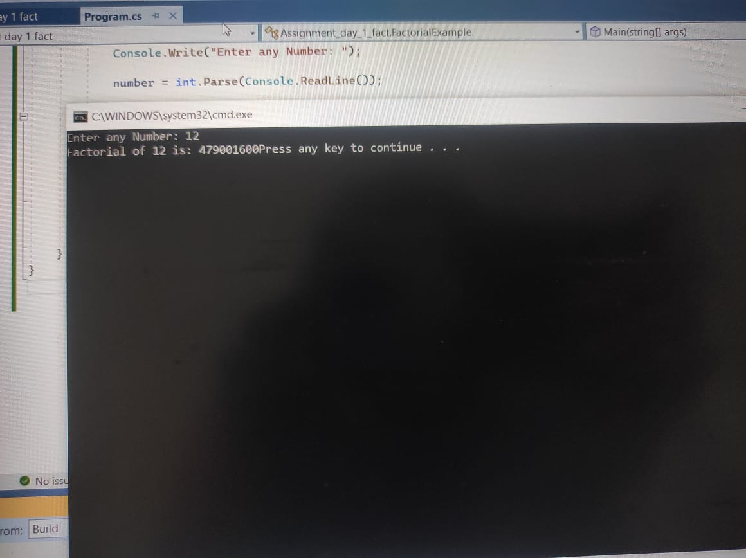

Output Factorial

Question no 2 Simple Interest

using System;

using System.Collections.Generic;

using System.Linq;

using System.Text;

using System.Threading.Tasks;

namespace assignment_day_1

{

internal class Program

{

static void Main(string[] args)

{

int year;

double priamt, interest, si;

Console.WriteLine("enter the principal amount");

priamt = Convert.ToDouble(Console.ReadLine());

Console.WriteLine("enter the number of years ");

year = Convert.ToInt16 (Console.ReadLine()) ;

Console.WriteLine("enter the rate of interest");

interest = Convert.ToDouble(Console.ReadLine());

si = (priamt * interest * year) / 100;

Console.WriteLine("si = {0}",si);

Console.ReadLine();

}

}

}

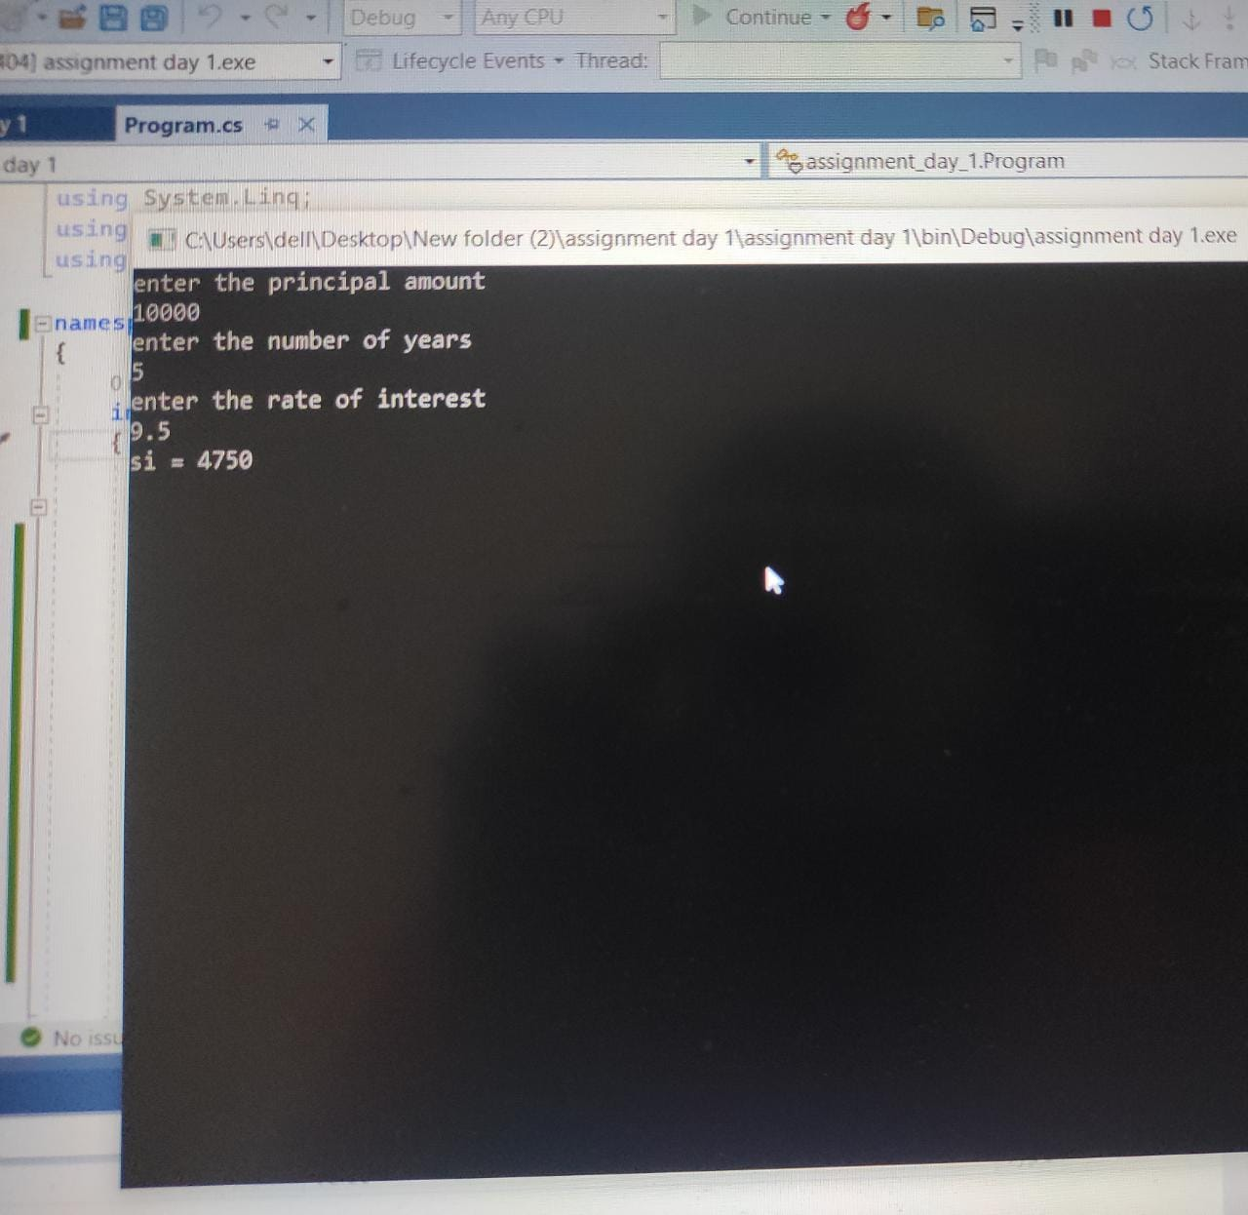

Output : SI

Question no 3 Average Marks Calculation

using System;

using System.Collections.Generic;

using System.Linq;

using System.Text;

using System.Threading.Tasks;

namespace Assignmentday1Averagemarks

{

class student

{

double physics, chemistry, math, roll_no, average;

string name, grade;

void fetchMarks()

{

Console.WriteLine("Enter the Name");

this.name = Console.ReadLine();

Console.WriteLine("Enter the Roll no");

this.roll_no = Convert.ToDouble(Console.ReadLine());

Console.WriteLine("Enter Physics Marks");

this.physics = Convert.ToDouble(Console.ReadLine());

Console.WriteLine("Enter Chemistry Marks");

this.chemistry = Convert.ToDouble(Console.ReadLine());

Console.WriteLine("Enter Maths Marks");

this.math = Convert.ToDouble(Console.ReadLine());

}

void AvgCalculation()

{

average = (this.physics + this.chemistry + this.math) / 3;

if (average >= 80)

{

this.grade = "First Class";

}

else if (average >= 60)

{

this.grade = "Second Class";

}

else

{

this.grade = "Pass Grade";

}

Console.WriteLine("Name of student:" + this.name + "Roll no:" + this.roll_no + "Grade:" + this.grade + "Average:" + average);

}

class Student

{

public static void Main()

{

student s = new student();

s.fetchMarks();

s.AvgCalculation();

}

}

}

}

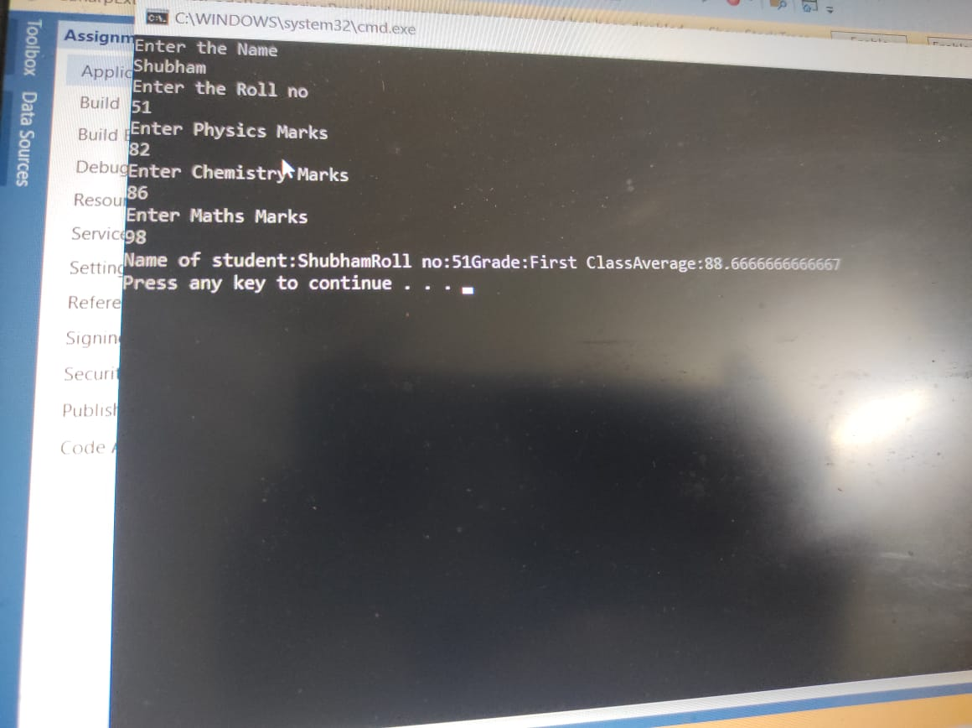

Question no 4 Bank Account

using System;

using System.Collections.Generic;

using System.Linq;

using System.Text;

using System.Threading.Tasks;

namespace oop3

{

class bank

{

private double balance = 100000;

public double bal

{

get { return balance;}

set { balance = value; }

}

}

class fuctions

{

bank i = new bank();

string name;

int account;

double withdraw, dep,tobal;

public void fun1()

{

Console.WriteLine("Enter Name of the depositor :");

name = Console.ReadLine();

Console.WriteLine("Enter Account Number :");

account = Convert.ToInt32(Console.ReadLine());

Console.WriteLine("Enter Deposit Amount :");

dep = Convert.ToDouble(Console.ReadLine());

tobal = i.bal + dep;

Console.WriteLine("------------------------------\n");

Console.WriteLine("Name of the depositor : " + name);

Console.WriteLine("Account Number: " + account);

Console.WriteLine("Total Balance amount in the account : " +tobal);

}

public void fun2()

{

Console.WriteLine("Enter Account Name :");

name = Console.ReadLine();

Console.WriteLine("Enter Account Number :");

account = Convert.ToInt32(Console.ReadLine());

Console.WriteLine("Enter Withdraw Amount :");

withdraw = Convert.ToDouble(Console.ReadLine());

if (withdraw <= i.bal)

{

tobal = i.bal - withdraw;

Console.WriteLine("------------------------------\n");

Console.WriteLine("Account Name : " + name);

Console.WriteLine("Account Number: " + account);

Console.WriteLine("After Withdraw Amount balnace is : " + tobal);

}

else

Console.WriteLine("\n\nWithdraw Ammount does not Exist your Account.");

}

}

class Program

{

static void Main(string[] args)

{

char agn;

do

{

fuctions k = new fuctions();

int num;

Console.WriteLine("Please Select Any Function.");

Console.WriteLine("\nPress 1 for Deposit an Amount. \nPress 2 for Withdraw an Amount.");

num = Convert.ToInt32(Console.ReadLine());

switch (num)

{

case 1:

k.fun1();

break;

case 2:

k.fun2();

break;

default:

Console.WriteLine("Invalid Selection!!!");

break;

}

Console.WriteLine("\nDo you want to continue this program? (y/n)");

agn =Convert.ToChar(Console.ReadLine());

} while (agn == 'y');

Console.ReadKey();

}

}

}

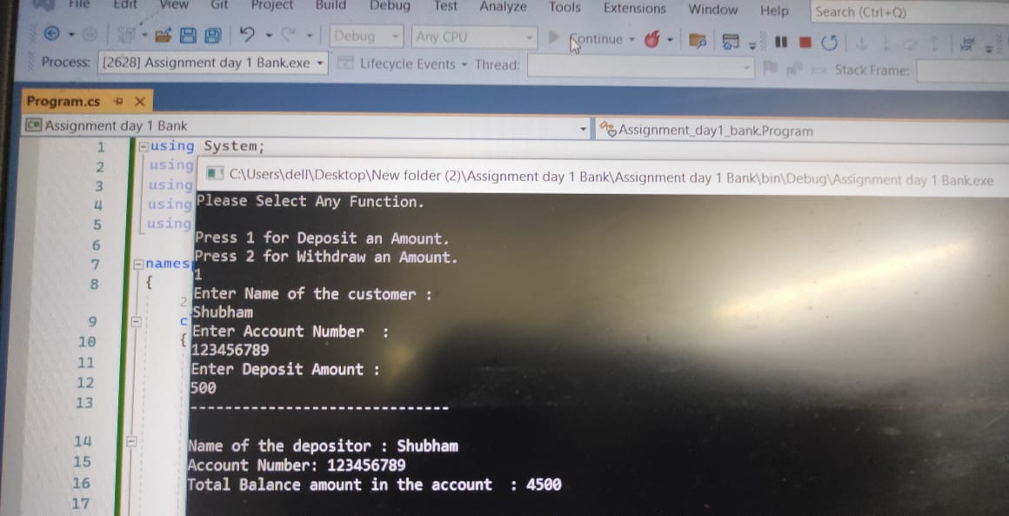

Question Default and parametrized constructors

using System;

using System.Collections.Generic;

using System.Linq;

using System.Text;

using System.Threading.Tasks;

namespace Training_Day1

{

class Customer

{

int id;

string customername, address, city;

double phone;

Customer(int id, string cname, string add, string city, double ph)

{

this.id = id;

this.customername = cname;

this.address = add;

this.city = city;

this.phone = ph;

}

Customer()

{

this.id = 1;

this.customername = "default";

this.address = "default";

this.city = "default";

this.phone = 1;

}

void disp()

{

Console.WriteLine("id:" + this.id);

Console.WriteLine("name : " + this.customername);

Console.WriteLine("add : " + this.address);

Console.WriteLine("City: " + this.city);

Console.WriteLine("Phone : " + this.phone);

}

class temp

{

public static void Main()

{

Customer c1 = new Customer();

Customer c2 = new Customer(2, "Suvit", " Niwara housing society ", "Shirdi", 8668729932);

Customer c3 = new Customer(3,"rahul", "sai siddhi appartment", "Shirdi", 9767571444);

c1.disp();

c2.disp();

c3.disp();

}

}

}

}

